Homework #6

# Creating HTML tables, from Felke textbook

**DUE: Tues Nov 28, 11:59pm.** (Accepted up to Fri Dec 22 11:59pm.)

Instructions:

1. Locate the files needed: Find the files needed for this homework assignment in the folder *BasicsOfWebDes_resources*, which is in the folder *Activities – Tables (Felke book), Apr 3*. See **Diagram 1** below:

**Diagram 1**

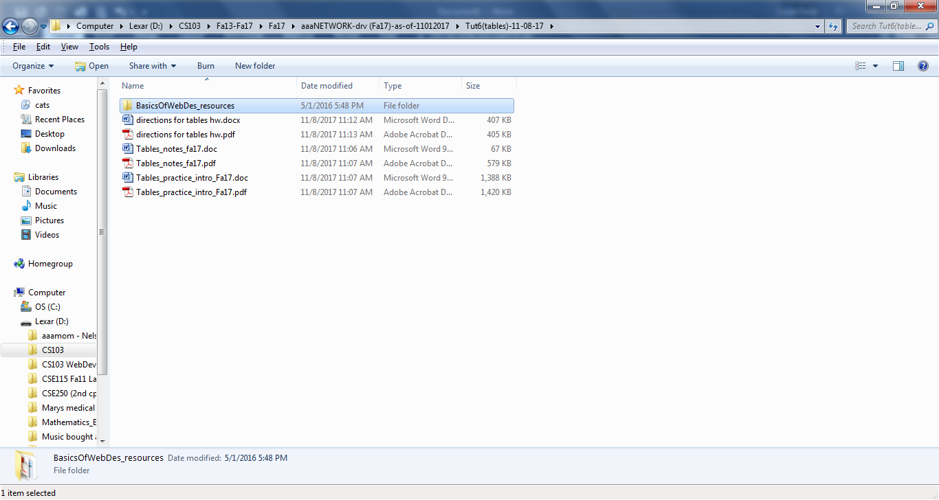

1. In *BasicsOfWebDes_resources* folder, locate the pdf file called **BasicWebDesign_pp285‑300.pdf.** See **Diagram 2** below.

**Diagram 2**

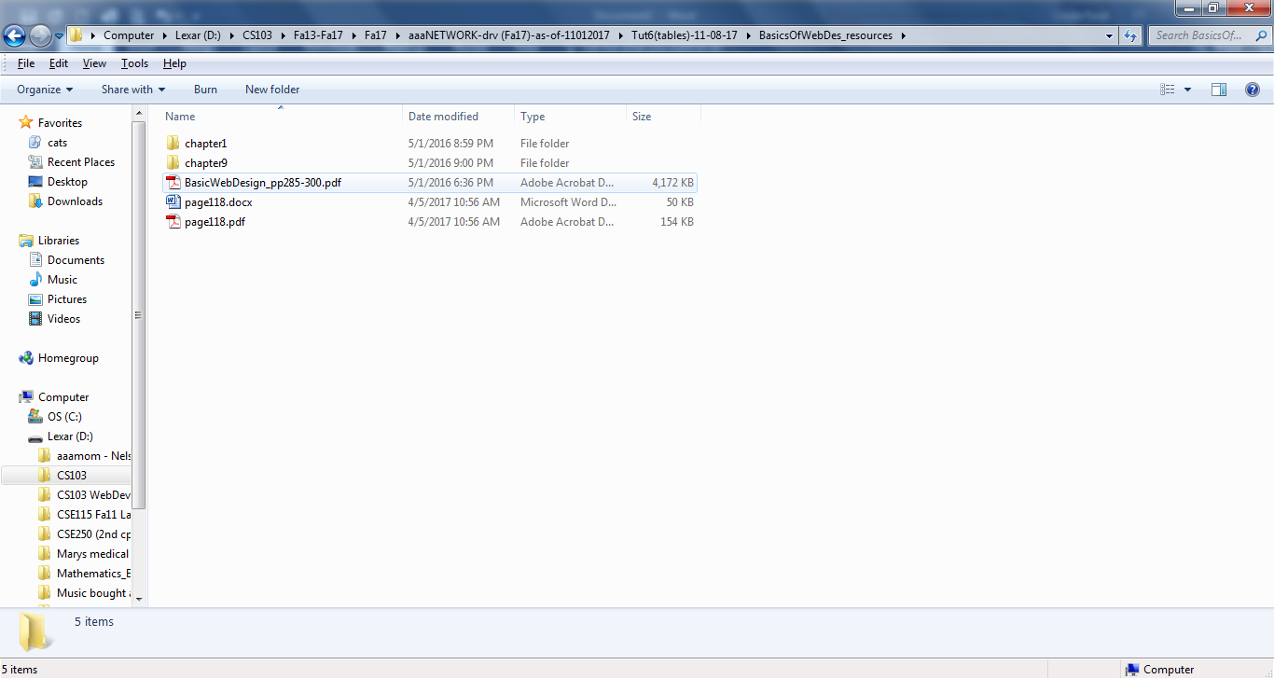

This pdf file contains a 15-page excerpt from a different textbook named *The Basics of Web Design* by Terry Felke-Morris. (You will be referred to the p118 pdf from within the 15-pages.)

1. Read this 15-page book excerpt. It is pages 285‑299 with pages 296-297 intentionally omitted. As you read you may want to complete the Hands-on Practice 9.1, 9.2, and 9.3 as well as the Review Questions #1‑10 (but omit #2) on p300, but this is **optional**. Find all necessary files (and solutions) for these hands-on practice exercises in the folder called *Chapter 9* which is also in the *BasicsOfWebDes_resources* Folder. See bottom of the next page for details on the reading.
2. Complete the following:
   1. p300 #1 and name it **birthday_table.html**
   2. p301 #2 and name it **school_sched.html**
   3. Extra Credit: Start with **school_sched.html** file that you just completed in the previous item and rename it **school_sched_mod.html**. Insert embedded styles to modify the table’s border(s), background-color and also to center it. To center the table, use:

table {

width: 75%;

margin: auto

}

Modify the border using one of the border styles.[1] Modify the border around the entire table or the borders around the cells or both. Apply background-color to all the cells or to just particular cells. You may want to refer to the folder in this activities folder called **CSS for Tables OPTIONAL** or pp442-445 of Session 6.1 in the textbook, *Adding Table Borders With CSS*.

* 1. Zip the 2 (or 3) files together and name the zip file **tables_yourlastname**.Drop it in the **tables Drop Box** in the *Homework & Drop Boxes* folder, located in the *Lessons* module of Brightspace.



Below is the outline of what to skip in the 15-page Felke textbook excerpt:

* For the test, you do not need to know any new CSS styles.
* “scope” is not required, (p288 and 293).
* On page 294, Table 9-2, be familiar with the 4 deprecated HTML attributes -- border, cellpadding, cellspacing, and bgcolor. Table 9-2 also contains styles but see bullet one above.
* Hands-on Practice 9-3 on pp294-295 is optional.
* For the Review Questions on p300, skip #2.

Note: FYI: You may refer to Tutorial 6 in our textbook which covers tables, but that is optional since we are using the Felke book excerpt.

1. See **boxmodel** notes in *Session_4-1* folder of *Activities – Tutorial 3 & 4, Oct 31* folder for info on border styles. (In MindTap reader it’s sections 4-4, 4-4a and 4-4b.)